File permissions in Linux

Project description
You are a security professional at a large organization. You mainly work with their research team. Part of your job is to ensure users on this team are authorized with the appropriate permissions. This helps keep the system secure.
Your task is to examine existing permissions on the file system. You’ll need to determine if the permissions match the authorization that should be given. If they do not match, you’ll need to modify the permissions to authorize the appropriate users and remove any unauthorized access.

Check file and directory details
In this task, you must explore the permissions of the projects directory and the files it contains. The lab starts with /home/researcher2 as the current working directory. This is because you're changing permissions for files and directories belonging to the researcher2 user.

- Navigate to the projects directory.
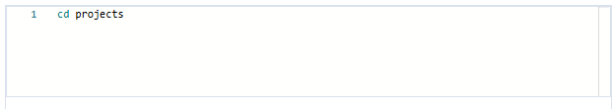

- List the contents and permissions of the projects directory.

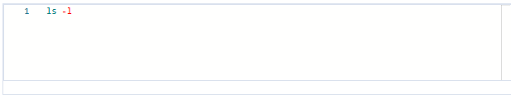

The permissions of the files in the projects directory are as follows:
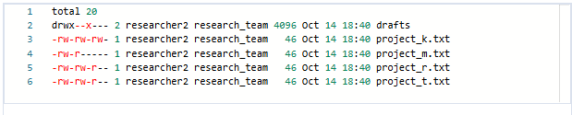

Describe the permissions string
- The 1st character indicates the file type. The d indicates it’s a directory. When this character is a hyphen (-), it's a regular file.
- The 2nd-4th characters indicate the read (r), write (w), and execute (x) permissions for the user. When one of these characters is a hyphen (-) instead, it indicates that this permission is not granted to the user.
- The 5th-7th characters indicate the read (r), write (w), and execute (x) permissions for the group. When one of these characters is a hyphen (-) instead, it indicates that this permission is not granted for the group.
- The 8th-10th characters indicate the read (r), write (w), and execute (x) permissions for the owner type of other. This owner type consists of all other users on the system apart from the user and the group. When one of these characters is a hyphen (-) instead, that indicates that this permission is not granted for other.

Change file permissions on a hidden file
- Change the permissions of the file .project_x.txt so that both the user and the group can read, but not write to, the file.

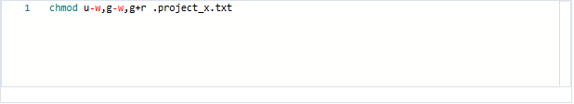

Change directory permissions
- Check the permissions of the drafts directory and answer the following question.
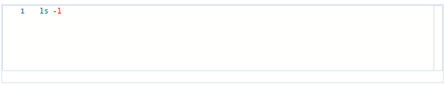
- Remove the execute permission for the group from the drafts directory.
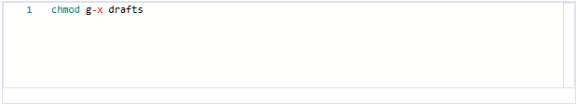

Summary
In this activity, I examined and managed file permissions in Linux for the researcher2 user to ensure that users on the research team were authorized with appropriate permissions and that unauthorized access was removed.

I navigated to the /home/researcher2/projects directory and used the ls -la command to list all files and directories, including hidden files and their current permissions, reviewing the 10-character permission string for each file to identify mismatches between existing permissions and intended authorization levels.

Using the chmod command, I corrected these mismatches by modifying the hidden file .project_x.txt so that both the user and the group had read only access and by removing the execute permission from the group on the drafts directory using chmod g-x drafts.

These actions ensured that all file and directory permissions aligned with the principle of least privilege, granting users only the access necessary for their roles while protecting the system from unauthorized access.

